**8-bit Calculator**

*Team Exemplary*

*24.06.2022*

# Team members

* Asm Nurussafa
* Tasawar Siddiquy
* Nirojan Navaratnarajah
* Arfat Kamal

# Introduction

*Introduction into your project*

*Why are FPGAs and VHDL important for your project domain?*

The goal of our project this semester is to build a 8-bit unsigned calculator. Our project design goal will perform the following arithmetic operations: 8-bit binary addition, subtraction, multiplication and division. All these operations are performed by combining different modules such as Adder, Subtractor, Multiplier and Divider using sub modules in which basic gates were used. Then, we design and code the following in VHDL and convert the schematics to PCB layout and then, fabricate it. All the softwares used for each step will be discussed further in the paper.

# Concept description

***Block diagram of your target application.***

***What is the main application for your prototype?***

1. Block diagram of our application:

1. Application domain of our project:

The inputs of the System are fed into the first four blocks in the form of binary values using the slide switches found in the PCB , they will then produce the outputs of the two numbers multiplied, added, subtracted and divided using the individual blocks shown. These values from the individual components are then the inputs to the 4:1 Multiplexer. Then 1-bit binary values are fed to the multiplexer which is called the selector inputs. These selector inputs decide on which operation is intended by the user and select the appropriate driver line and send to the decoder. It is here where the output from the multiplexer is decoded to values which is able to display decimal values on the 7 segment displays. The displays are four separate devices and therefore a decoding algorithm which is using a bit shifting and adding mechanism is implemented.

The main application of our prototype is to do simple addition, subtraction, multiplication and division.

# Project/Team management

To realize our project, we have decided to use a sort of the iterative development model. This will allow us to work on our project and test our scenario iteratively, meaning it lets us go back to previous steps and work on it and then, move on forward as we seem necessary. To organize the project in an orderly manner and to avoid miscommunication, we divided specific works for ourselves and held weekly meetings to comment on our progress and to decide on future tasks. When implementing, we got together in person as often as we could and worked on to realise our target scenario. A documentation of each group member`s progress is shown below. The dates stated indicate we had a meeting in each of these dates.

# Technologies

# *Describe the technological approaches you will use to implement your project.*

* *VHDL*
* *Eagle*
* *FPGA*
* *If necesseray other technologies*

1. VHDL:

The **VHSIC Hardware Description Language** (**VHDL**) is a hardware description language (HDL) that can model the behavior and structure of digital systems at multiple levels of abstraction, ranging from the system level down to that of logic gates, for design entry, documentation, and verification purposes.

To begin implementing the code the Software Modelsim is used, it is a software targeted for Intel® FPGAs devices, which is a multi-language environment by Siemens, previously developed by Mentor Graphics.

1. Autocad Eagle:

EAGLE is electronic design automation (EDA) software that lets printed circuit board (PCB) designers easily connect schematic diagrams, component placement, PCB routing, and comprehensive library content.For this project it was a requirement to design a PCB which includes integration of FPGA module ,switches for inputs, and 7 Segment displays.

A two-layer PCB is designed which will be described in the upcoming sections.

1. FPGA

FPGA (Field Programmable Gate Array) is a hardware circuit that a user can program to carry out one or more logical operations. Taken a step further, FPGAs are integrated circuits, or ICs, which are sets of circuits on a chip—that's the “array” part. For this calculator project, the FPGA used is EP4CE22E22C8N from Intel. The library used is from Ultralibrarian.com.

Some of the specifications are as listed below:

* FGPA CyloneR IV E Family
* 22320 Cells 60nm technology
* 1.2 V
* 144-Pin EQFP EP

The Footprint,3D model and the Symbol are shown below.

1. Xilinx ISE

The Xilinx ISE is primarily used for circuit synthesis and design.

# VHDL Implementation

*Describe the implementation of your digital design in VHDL/FPGA*

*Provide a detailed block diagram for this purpose and briefly explain the used modules.*

*Describe how you verified your solution. Testbench!!*

*Provide the results for your FPGA Implementation (Results summary + Hardware results if necessary)*

As an initial step, basic components such as the Half adder, Full adder, ripple-carry adder were coded. Testbenches for each module are also made and the components are tested for valid output. In the next step, relatively larger modules like, 8-Bit adder, subtractor, multiplier, divider, decoder, and multiplexer were created.

1. Divider:

To realise the divider, the following block diagram was taken into account.

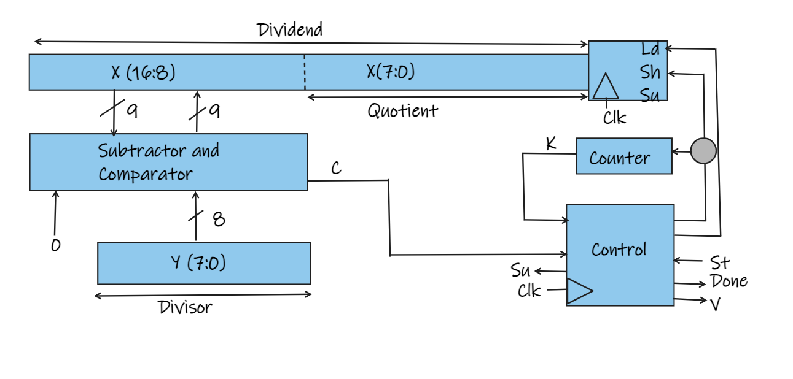

The division can be carried out by a series of subtraction and shift operations. To construct the divider, we will use a 17-bit dividend register and a 8-bit

divisor register, as shown in Figure . During the division process, instead of shifting the divisor to the right before each subtraction like in the multiplication, we will shift the dividend to the left. Note that an extra bit is required on the left end of the dividend register so that a bit is not lost when the dividend is shifted left. Instead of using a separate register to store the quotient, we will enter the quotient bit-by-bit into the right end of the dividend register as the dividend is shifted left.

The following was finite state machine was created in order to realize the control circuit:

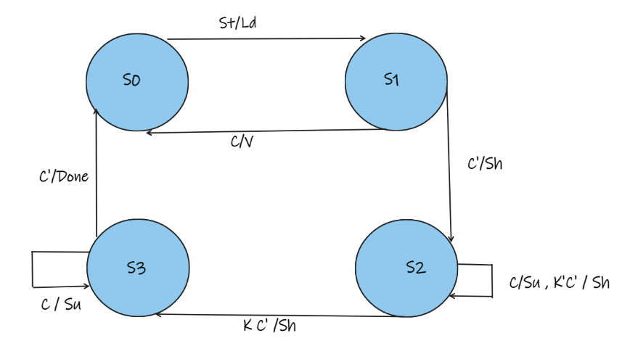

When a start signal (*St*) occurs, the 16-bit dividend and 8-bit divisor are loaded into the appropriate registers. If *C* is 1, the quotient would require 9 or more bits. Because space is only provided for a 8-bit quotient, this condition constitutes an overflow, so the divider

is stopped, and the overflow indicator is set by the *V* output. Normally, the initial

value of *C* is 0, so a shift will occur first, and the control circuit will go to state *S*2.

Then, if *C* = 1, subtraction occurs. After the subtraction is completed, *C* will always

be 0, so the next active clock edge will produce a shift. This process continues until

four shifts have occurred, and the control is in state *S*3. Then, a final subtraction

occurs if *C* =1, and no subtraction occurs if *C* = 0. No further shifting is required,

and the control goes to the stop state. For this example, we will assume that when

the start signal (*St*) occurs, it will be 1 for one clock time, and, then, it will remain

0 until the control circuit is back in state *S*0. Therefore, *St* will always be 0 in states

*S*1 through *S*3.

Finally, these modules were used as components in the final project file, and they were all connected in a manner which produces the expected results as shown in the block diagram in section 3. With the final Testbench for the final project file, it is clear that the code is working as expected. Still the code needs more bug fixed and improvements, which can be solved by working more on the project. A picture illustrating the simulation of the Test Bench is shown below:     (This diagram needs to be updated with the divider option)

In the above shown diagram the Testbench is simulated , and as it is visible, inputs of “30” and “20” are given , each time when the selector changes,the answer (Outputs) in the 4th row also change. The second column indicates subtraction ,third - addition ,fourth- multiplication, and fifth- Division,(needs to be included)

# PCB Design

*Describe the implementation of your schematic and PCB design*

*Give a summary about your PCB design results (BOM, Costs, Size usw.)*

An image of the printed circuit board is shown below. (2 Layer PCB)

As mentioned earlier the software AutoCAD eagle is chosen for this PCB design.

Initially a research of which FPGA to be used for this project was carried out. From the Ultra-librarian website, the EP4CE22E22C8N library from Intel was available with the footprints and symbol, therefore this library was included in the software.

For the users to be able to enter the first and second numbers (in this case binary digits), one switch for each binary digit is chosen, and to simulate this with hardware, 8 sliding switches from the Sparkfun library were chosen for each input. In addition, the user is also able to select which operation to perform and therefore two additional sliding switches are included for this purpose. Resistors are also used in this case as pull down the voltage when no input is provided. After placing the components in the schematic area, they were all wired up using the net tool. Next, the option for board is switched from schematic and the placing of components were done in a manner that makes sense to use. After the completion of the components placing step, the auto router option was used to wire up each individual component. Since, there were too many connections, it was easier to start with AutoRoute and then manually alter some connection which did not fulfil the commands, like 90° bending of nets. The top and bottom layer is covered with a ground plate which makes it easier to make the GND connections and at the same time acts as a heat sink which helps to prevent heating up of the circuit board. A solder mask layer was applied to both the layers to protect the copper from oxidation and shorts during operation. As an additional step, ”vias” were placed in many locations which ensures good connection of the top and bottom layer Ground plates. To be able to mount the PCB on any surface or housing, four holes in the edges of the PCB are also provided. As a final step, a silk layer is added, where the certain texts such as Switch numbers, Team name, and other related texts were to be printed.

With this, the main part of the PCB for the project is ready, with inclusion of certain components such as power supply and J-Tag programmers and the clock (oscillator) the PCB will be fully complete and ready to be manufactured. Gerber files can then be generated and sent to the manufacturers for producing the physical PCB.(When complete and ready to be manufactured).

**BOM List ,Cost ,size**

Size of PCB -> 106 x 87mm

Total estimated cost : - $105.02

1. Limitations and restrictions:

* For subtraction – first number should be greater than second.(since signed numbers are not supported by the code.
* For multiplication answer can only be max 14 bits
* Input’s total should not be more than 14 bits in total  
  Eg : 7 bits and 7 bits, or 8 bits and 6 bits, etc.

# Sources/References

*Provide the sources on the technologies and algorithms you used in your project (Github).*

*Github Repository -* [*https://github.com/Asm-Nurussafa/Advanced-Embedded-System--Team-Exemplary*](https://github.com/Asm-Nurussafa/Advanced-Embedded-System--Team-Exemplary)

*[1]Implementation and simulation of MC68HC11 a thesis ... - researchgate. (n.d.). Retrieved May 17, 2022, from https://www.researchgate.net/profile/Cumhur-Tuncali-2/publication/301804902_Implementation_and_Simulation_of_MC68HC11_Microcontroller_Unit_Using_SystemC_for_Co-design_Studies/links/57290d1908aef5d48d2c907a/Implementation-and-Simulation-of-MC68HC11-Microcontroller-Unit-Using-SystemC-for-Co-design-Studies.pdf*

*[2]https://app.ultralibrarian.com/details/229a8561-a1bb-11ea-b5d0-0aebb021a1ea/Intel/EP4CE22E22C8N?uid=15679901*